1)

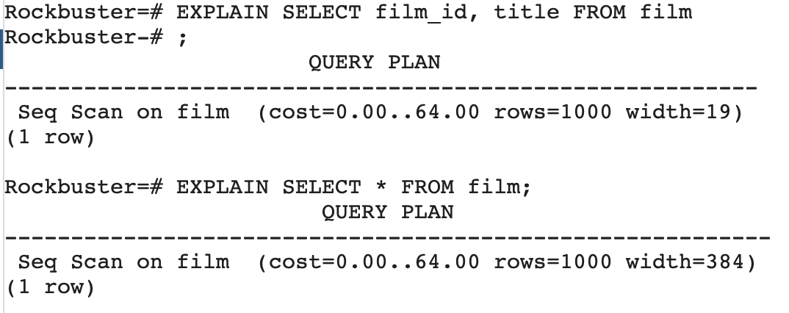

Well honestly I can’t explain myself why we have the same costs here. Usually it should cost less to execute the Query with the column names written out. That is what's said in [this](https://beginner-sql-tutorial.com/sql-query-tuning.htm) article:

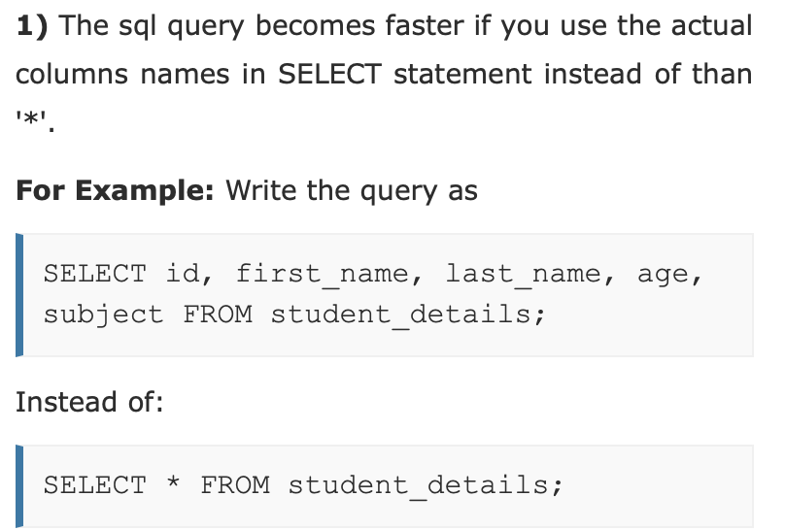

2)

ordered by title:

SELECT * FROM film ORDER BY title;

ordered by release year:

SELECT * FROM film ORDER BY release_year;

ordered by rental rate:

SELECT * FROM film ORDER BY rental_rate DESC;

3)

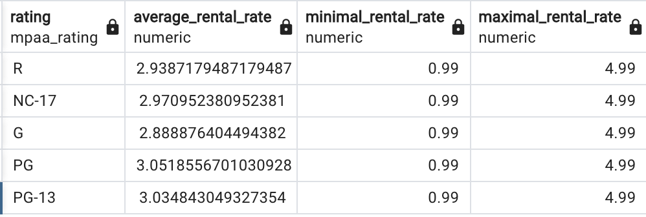

4)

The data must first be extracted from the old warehouse or other data source. After doing this, we must convert the data into a format that will allow us to use it and make it compatible with the layout of our warehouse. The data can then be loaded into a new or existing table in our database. Typically that's the job of the data engineer. Possible problems could be that the data we load into our data is additional information to already existing data. That way I wouldn’t be able to use the data. Also the Format of the data could be completely unfamiliar to me. If that's the case I would change the format and later on if someone else uses the same data he/she/it has to repeat this step.

Link to CSV document. Why I should paste only text into this file confused me.

<https://drive.google.com/file/d/177pEmj0XhoGjX2l_6rKGENs_CoA6aZPO/view?usp=sharing>